**Cozy Haven Stay – Hotel Booking System**

* **Sudharsana Inbakumar**

**Creation of New Connection**

**Step 1: Creating the new User (Schema) in SQL*Plus (Backend CMD)**

**1.1** **Connecting to FREEPDB1 as system:**

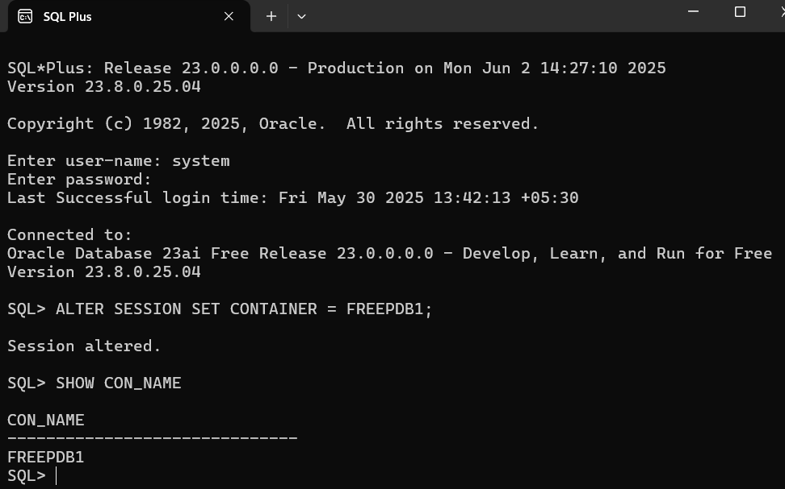

**1.2** **Creating the COZY_HAVEN_STAY_APP user and granting privileges:**

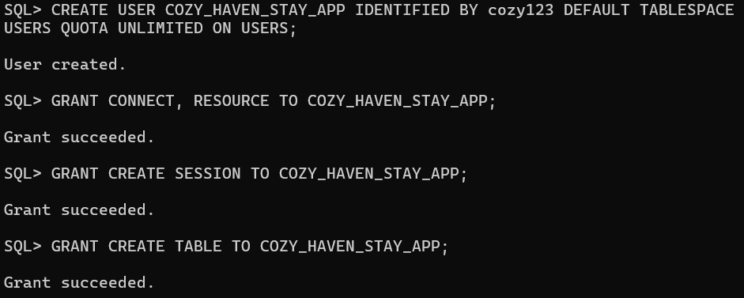

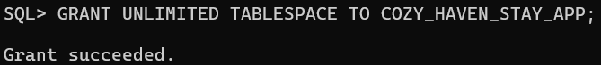

**Step 2: Creating the New Connection in SQL Developer**

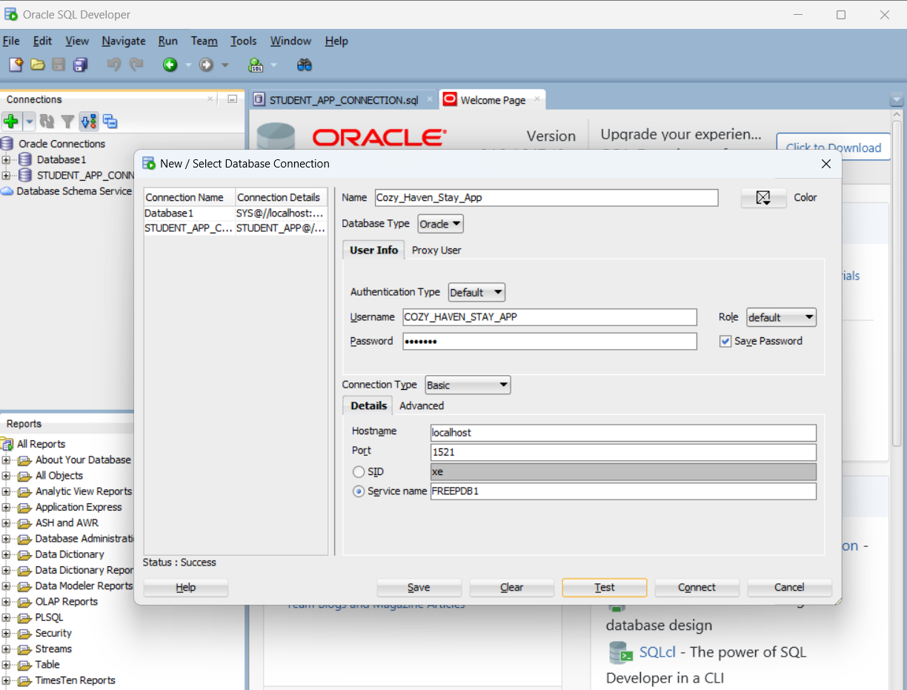

**Successfully created a new connection**

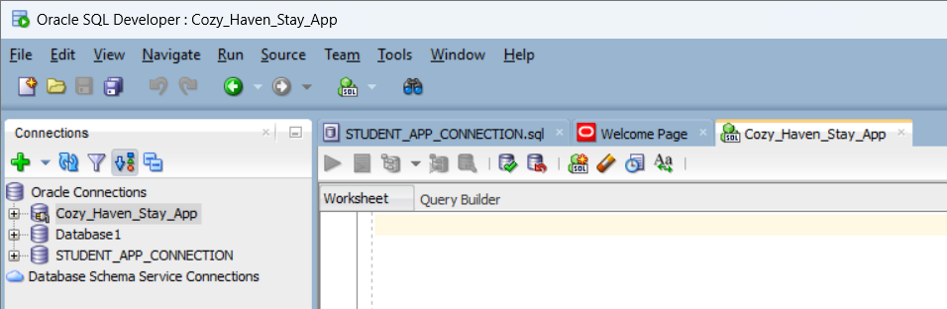

**Database Design:**

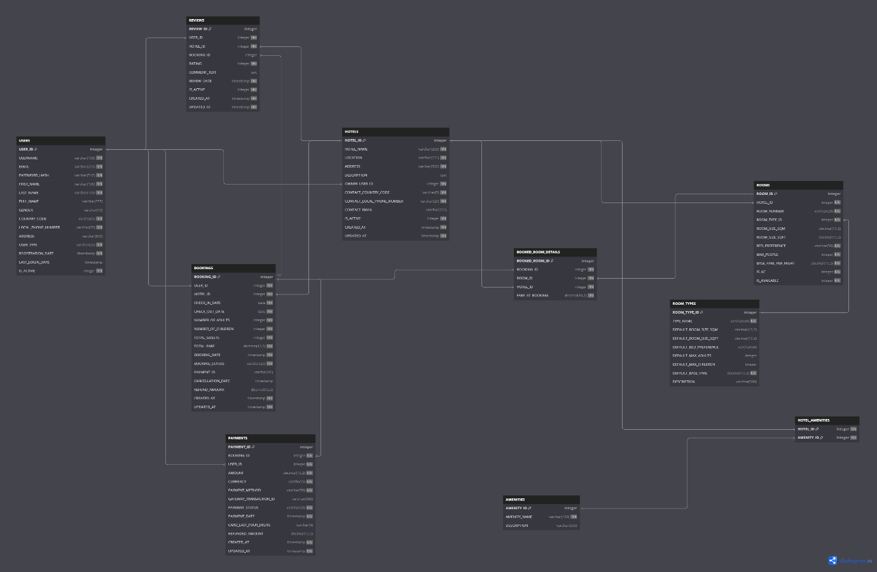

**Identification of Tables:**

1.Users

2.Hotels

3.Rooms

4.Room_Types

5.Bookings

6.Booked_Rooms_Details

7.Amenities

8.Hotel_Amenities

9.Payments

10.Reviews

**Relationship Mapping:**

|  |  |  |  |  |
| --- | --- | --- | --- | --- |
| Entity 1 | Relationship | Entity 2 | Cardinality | Significance |
| USERS | ***OWNS*** | **HOTELS** | **1:M** | One User (HOTEL_OWNER) can own multiple Hotels. |
| HOTELS | ***CONTAINS*** | **ROOMS** | **1:M** | One Hotel can have many Rooms of various types. |
| ROOM_TYPES | ***CATEGORIZES*** | **ROOMS** | **1:M** | One Room Type (e.g., "Deluxe") can categorize many individual Rooms. |
| USERS | ***BOOKS*** | **BOOKINGS** | **1:M** | One User (GUEST) can make multiple Bookings. |
| HOTELS | ***RECEIVES*** | **BOOKINGS** | **1:M** | One Hotel can receive many Bookings. |
| BOOKINGS | ***INCLUDES*** | **BOOKED_ROOM_DETAILS** | **1:M** | One Booking can include details for multiple Booked Room Details (if multiple rooms booked). |
| ROOMS | ***INCLUDED_IN*** | **BOOKED_ROOM_DETAILS** | **1:M** | One Room can be included in many Booked Room Details (over time if booked multiple times). |
| HOTELS | ***LINKED_TO*** | **BOOKED_ROOM_DETAILS** | **1:M** | One Hotel has many Booked Room Details associated with its rooms. |
| HOTELS | ***OFFERS*** | **AMENITIES** | **M:N** | A Hotel can offer many Amenities, and an Amenity can be offered by many Hotels (via junction). |
| BOOKINGS | ***HAS*** | **PAYMENTS** | **1:M** | One Booking can have multiple Payments (e.g., initial payment, refunds). |
| USERS | ***INITIATES*** | **PAYMENTS** | **1:M** | One User can initiate multiple Payments. |
| USERS | ***WRITES*** | **REVIEWS** | **1:M** | One User can write multiple Reviews. |
| HOTELS | ***RECEIVES*** | **REVIEWS** | **1:M** | One Hotel can receive many Reviews. |
| BOOKINGS | ***ASSOCIATED_WITH*** | **REVIEWS** | **1:0..1** | One Booking can be linked to at most one Review, but a Review might not always be linked. |

**Creation of Tables:**

**1.Users**

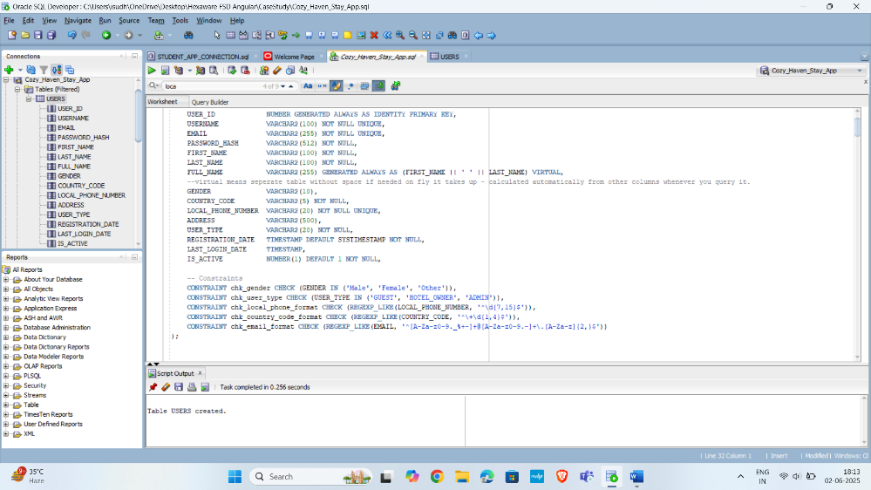

**2.Hotels**

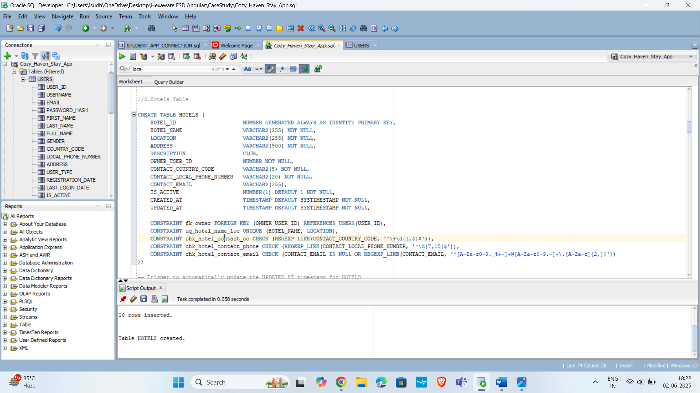

**3.Rooms**

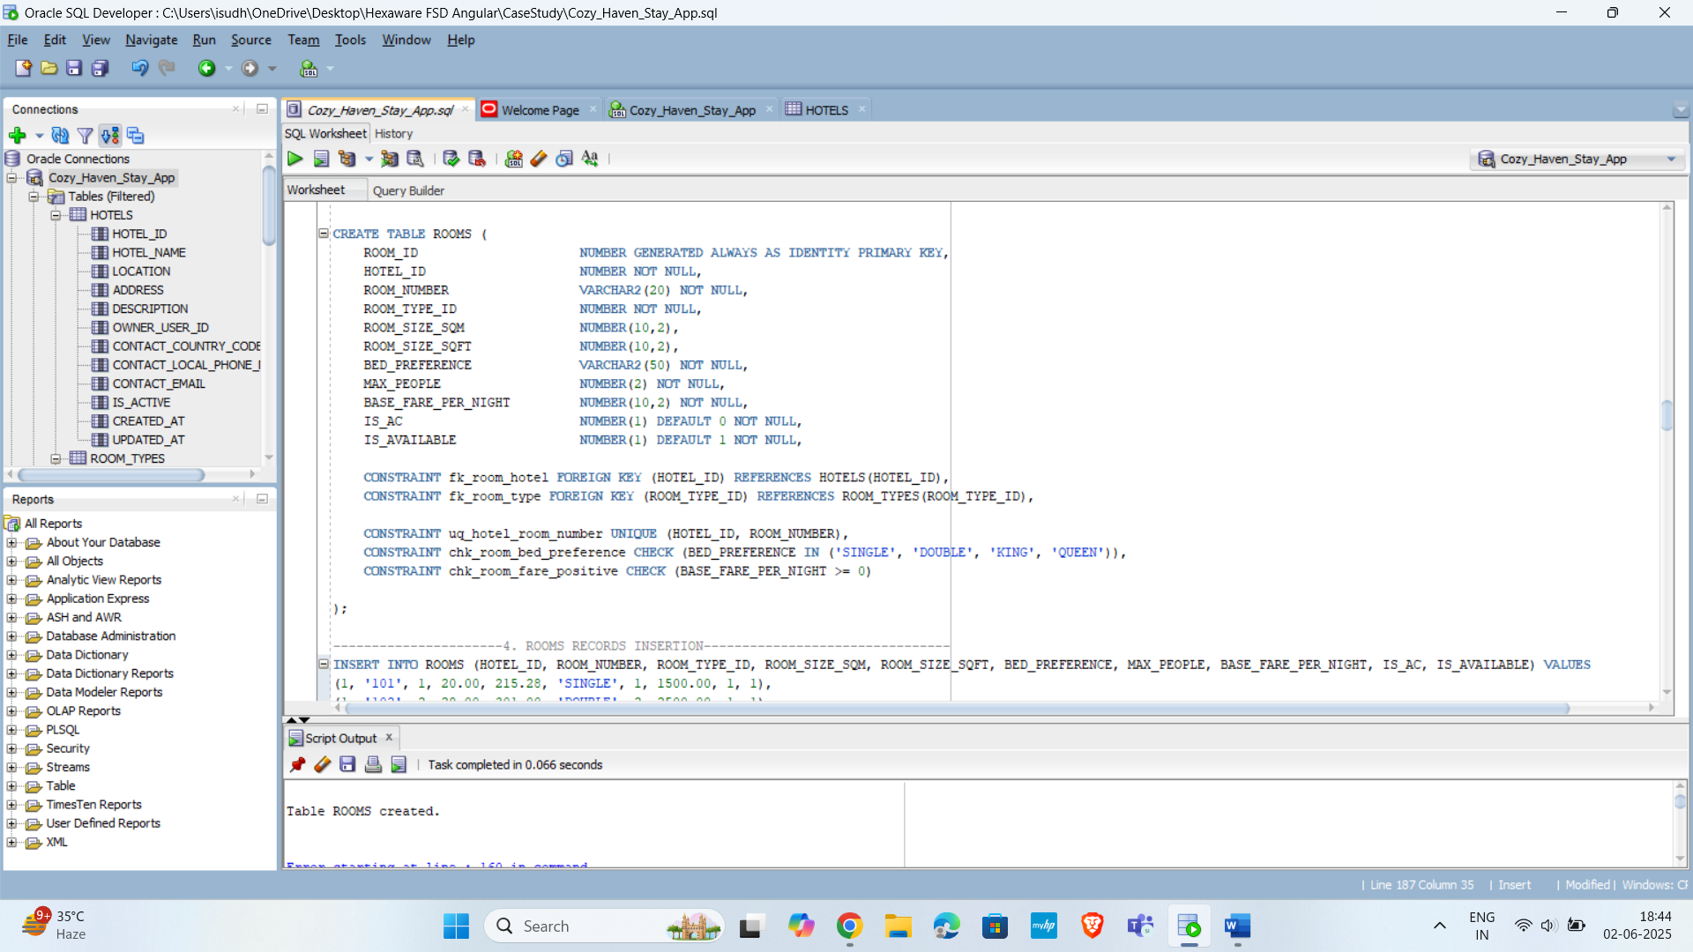

**4.Room_Types**

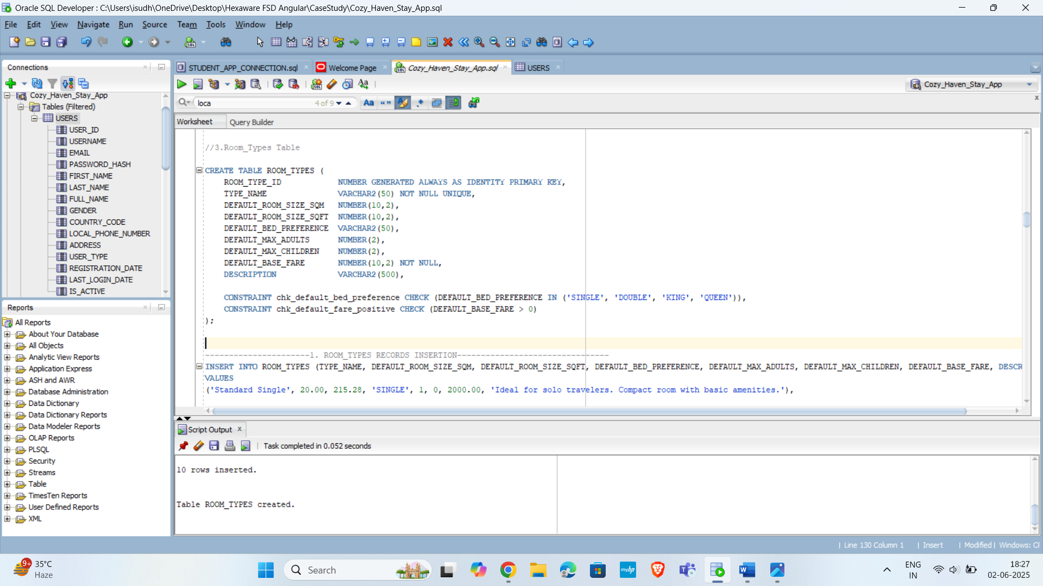

**5.Bookings**

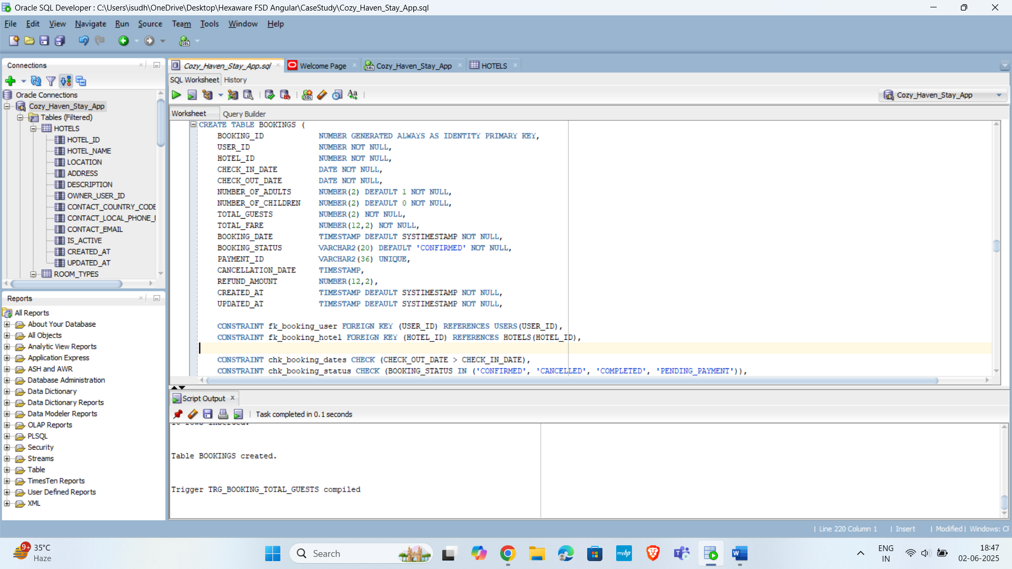

**6.Booked_Rooms_Details**

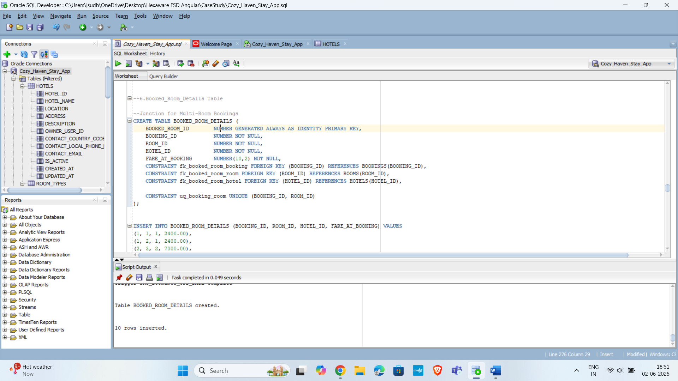

**7.Amenities**

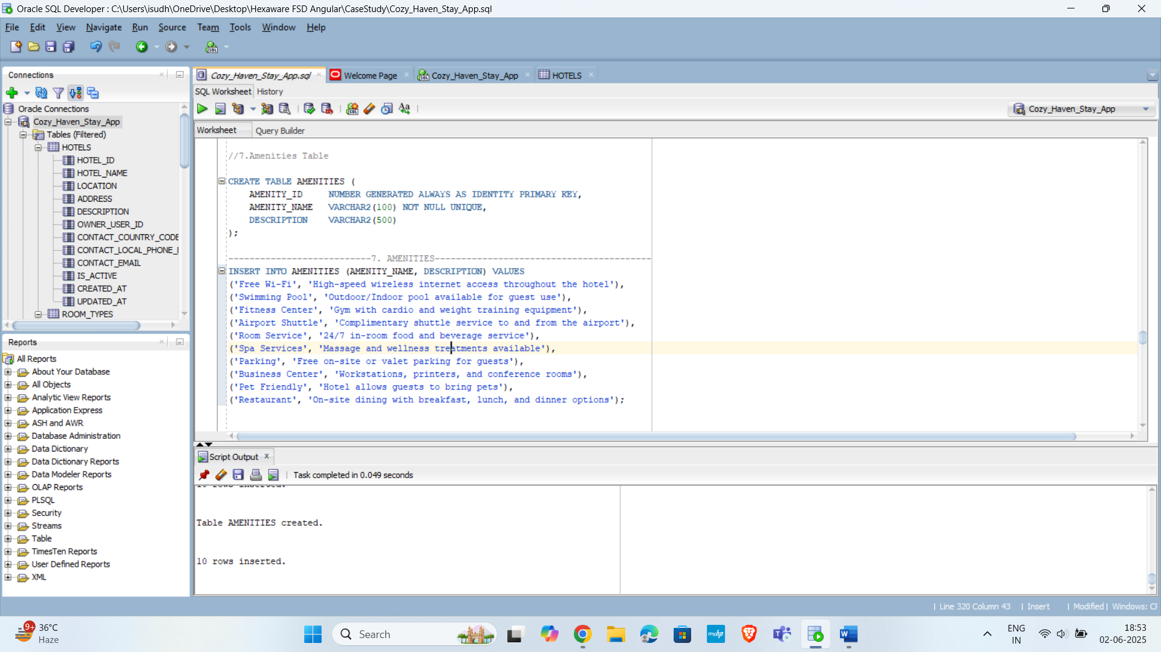

**8.Hotel_Amenities**

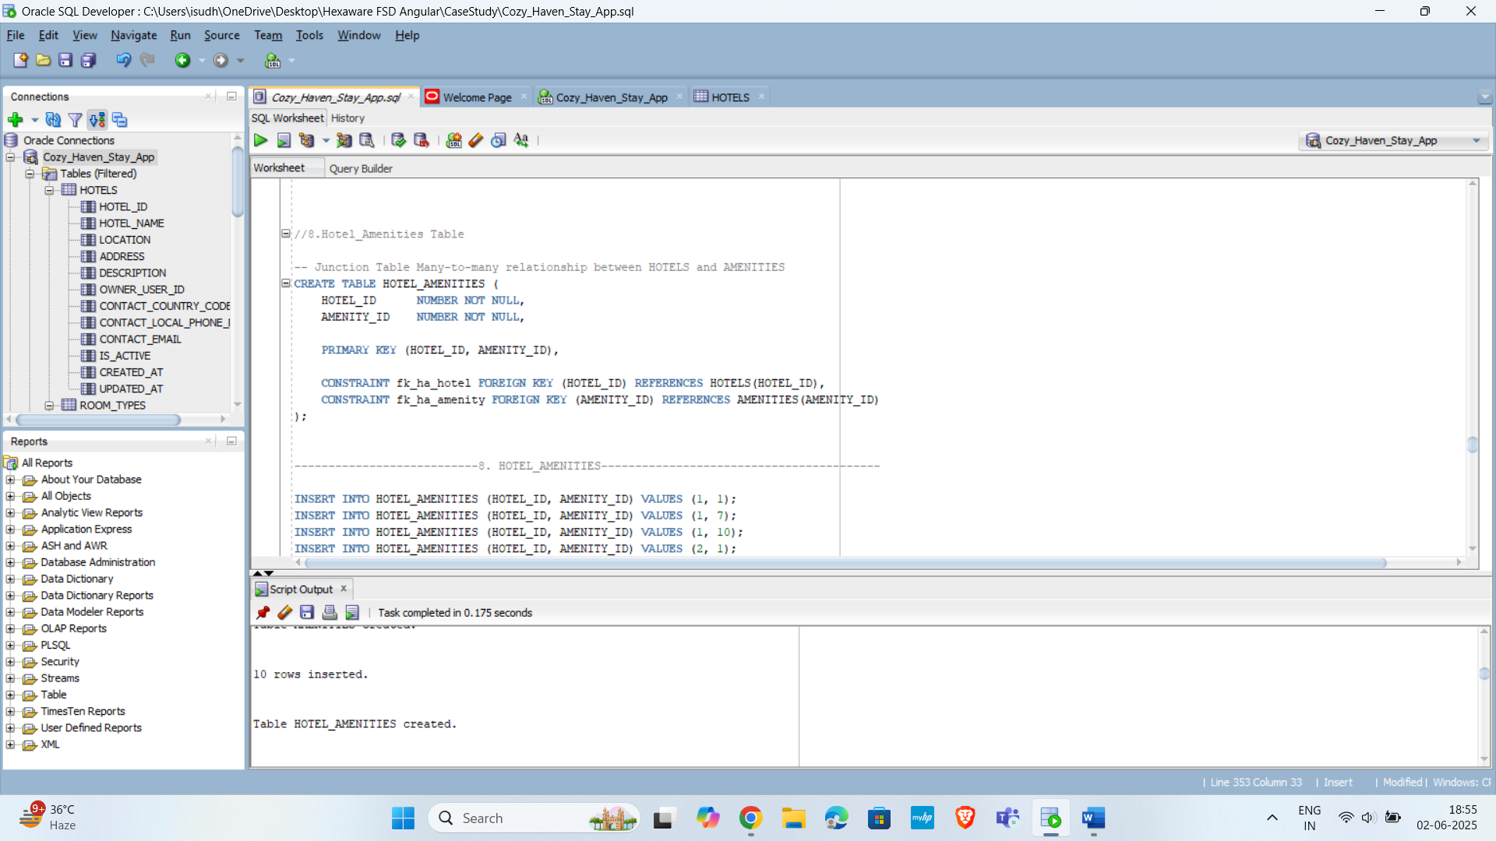

**9.Payments**

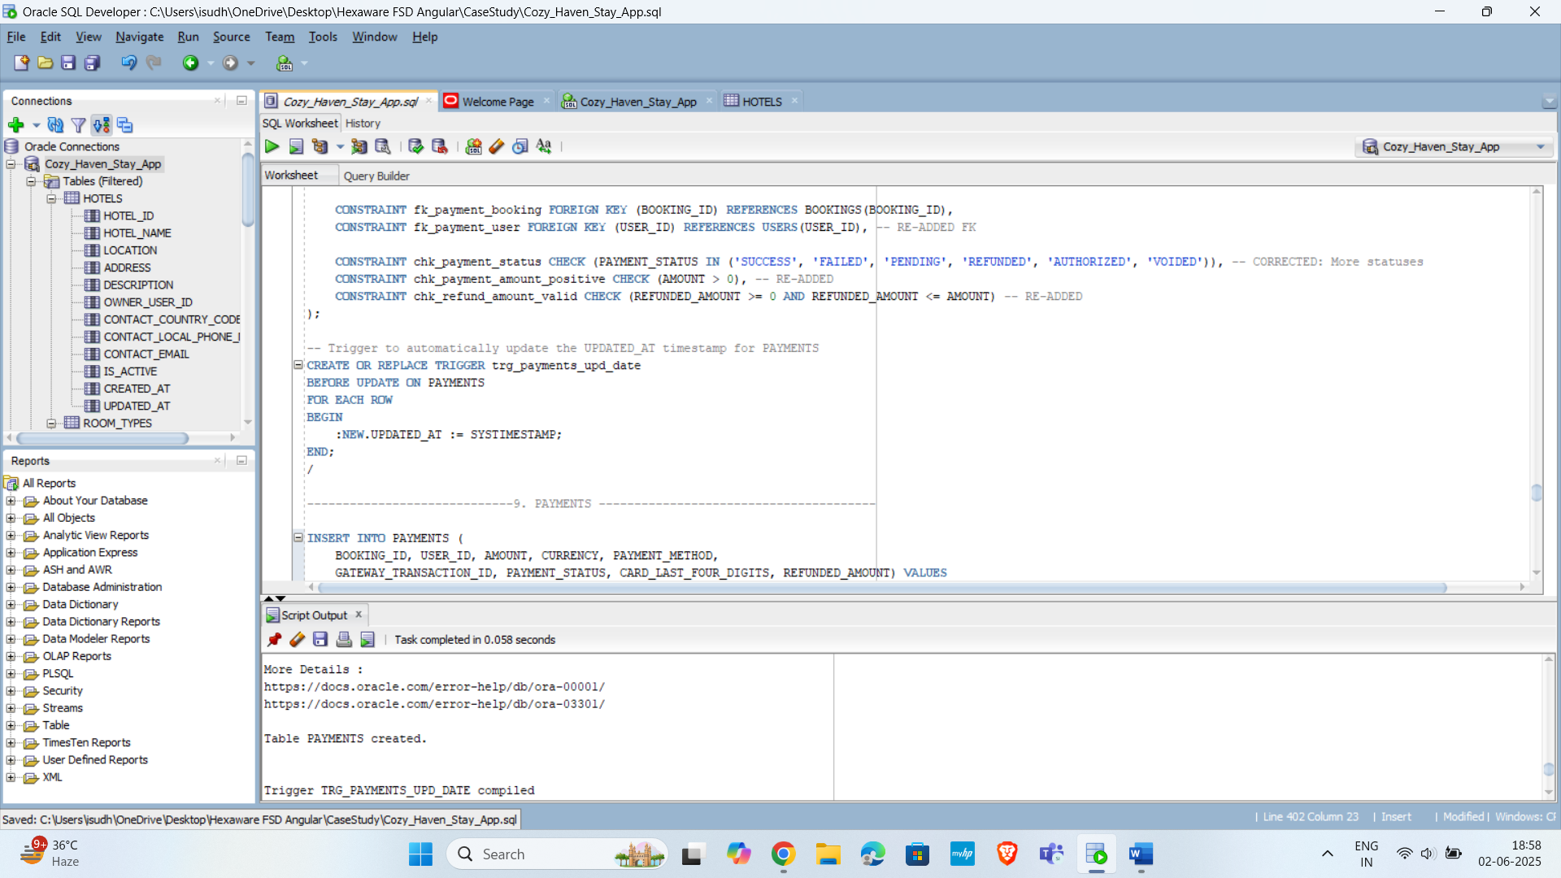

**10.Reviews**

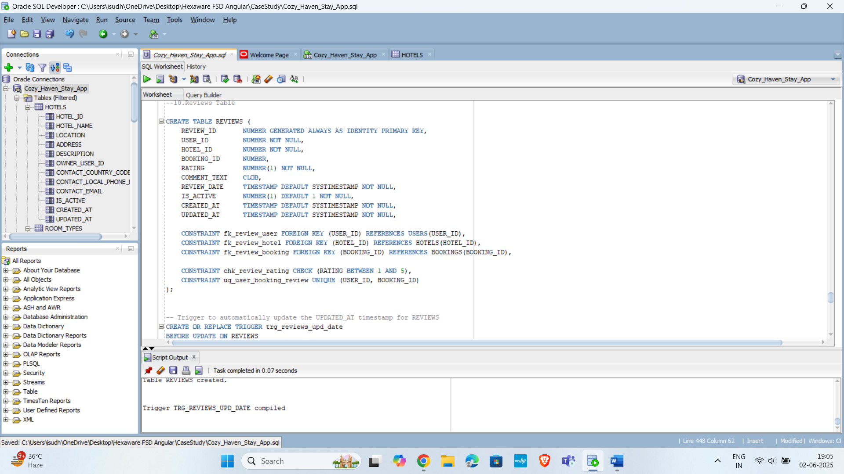

**Insertion of records in Tables:**

**1.Users**

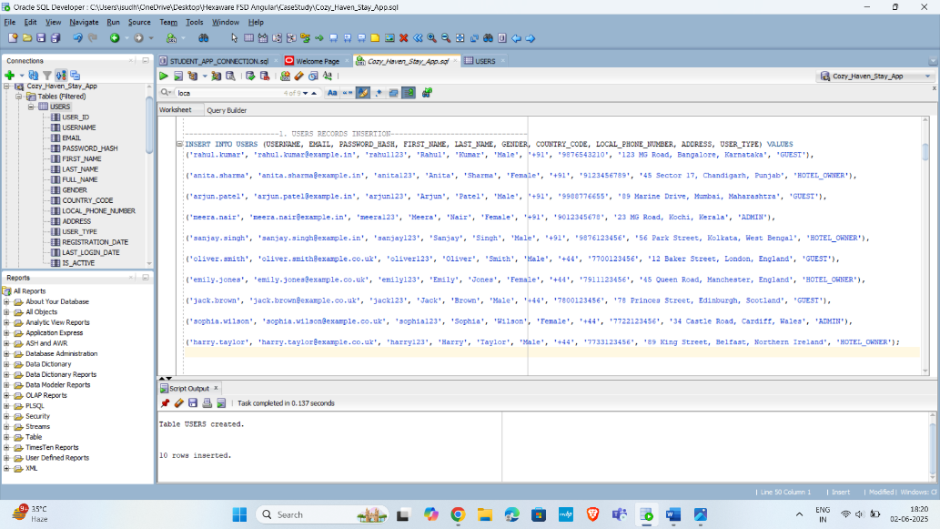

**2.Hotels**

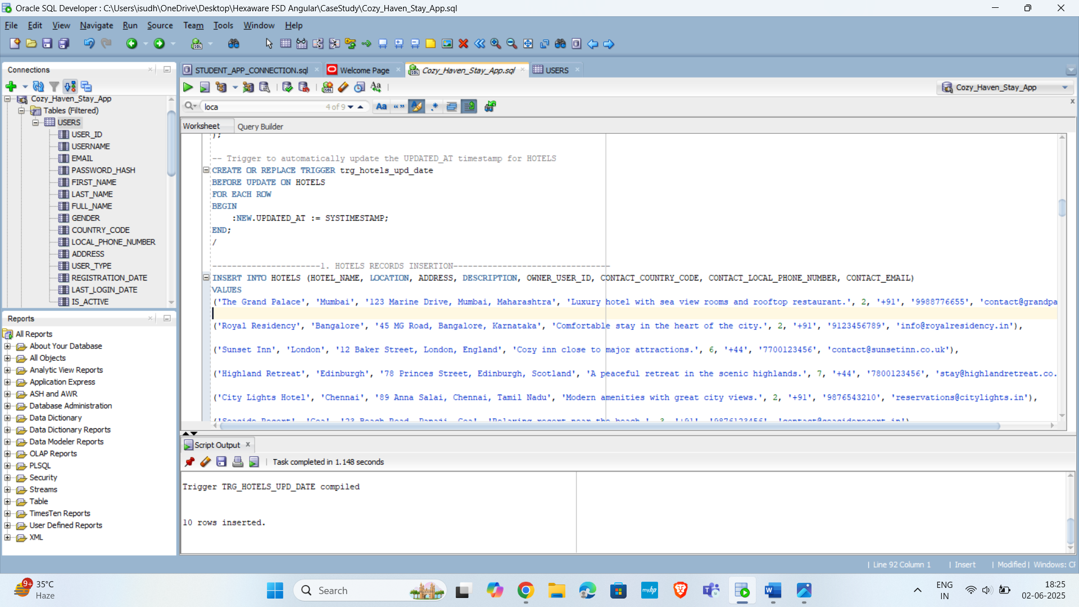

**3.Rooms**

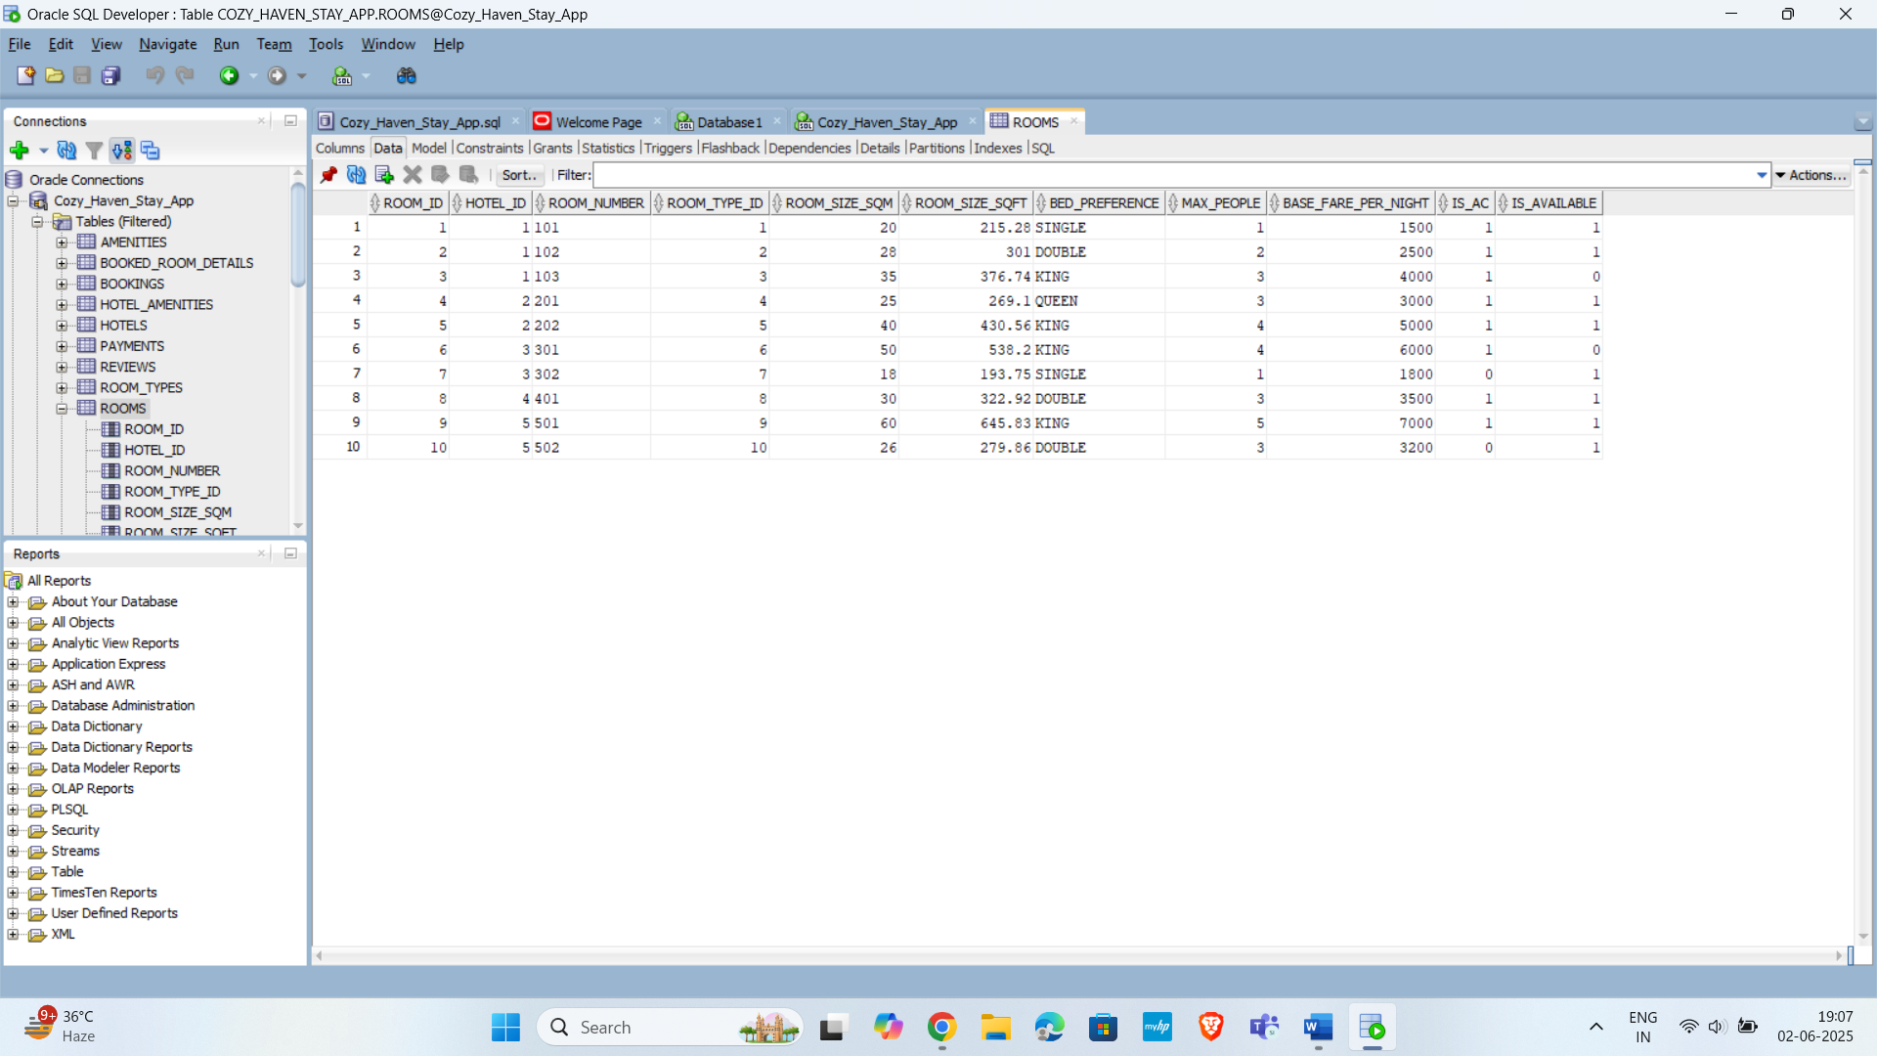

**4.Room_Types**

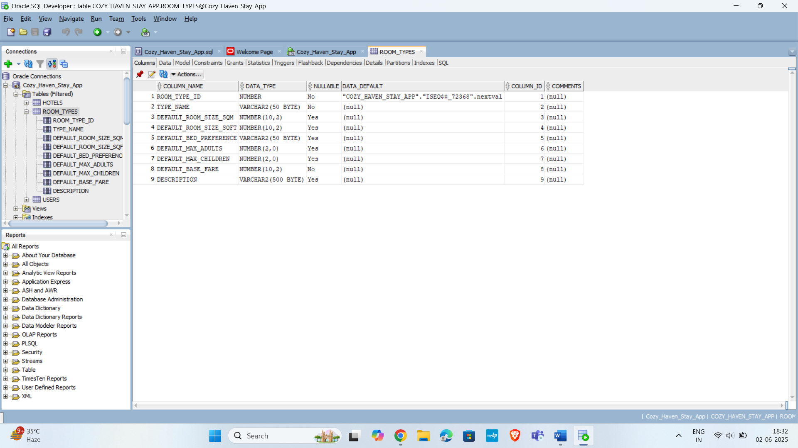

**5.Bookings**

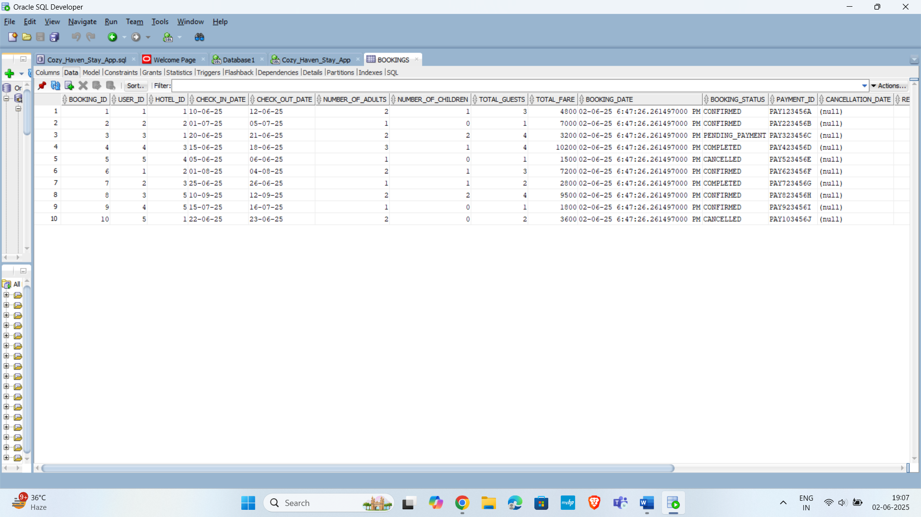

**6.Booked_Rooms_Details**

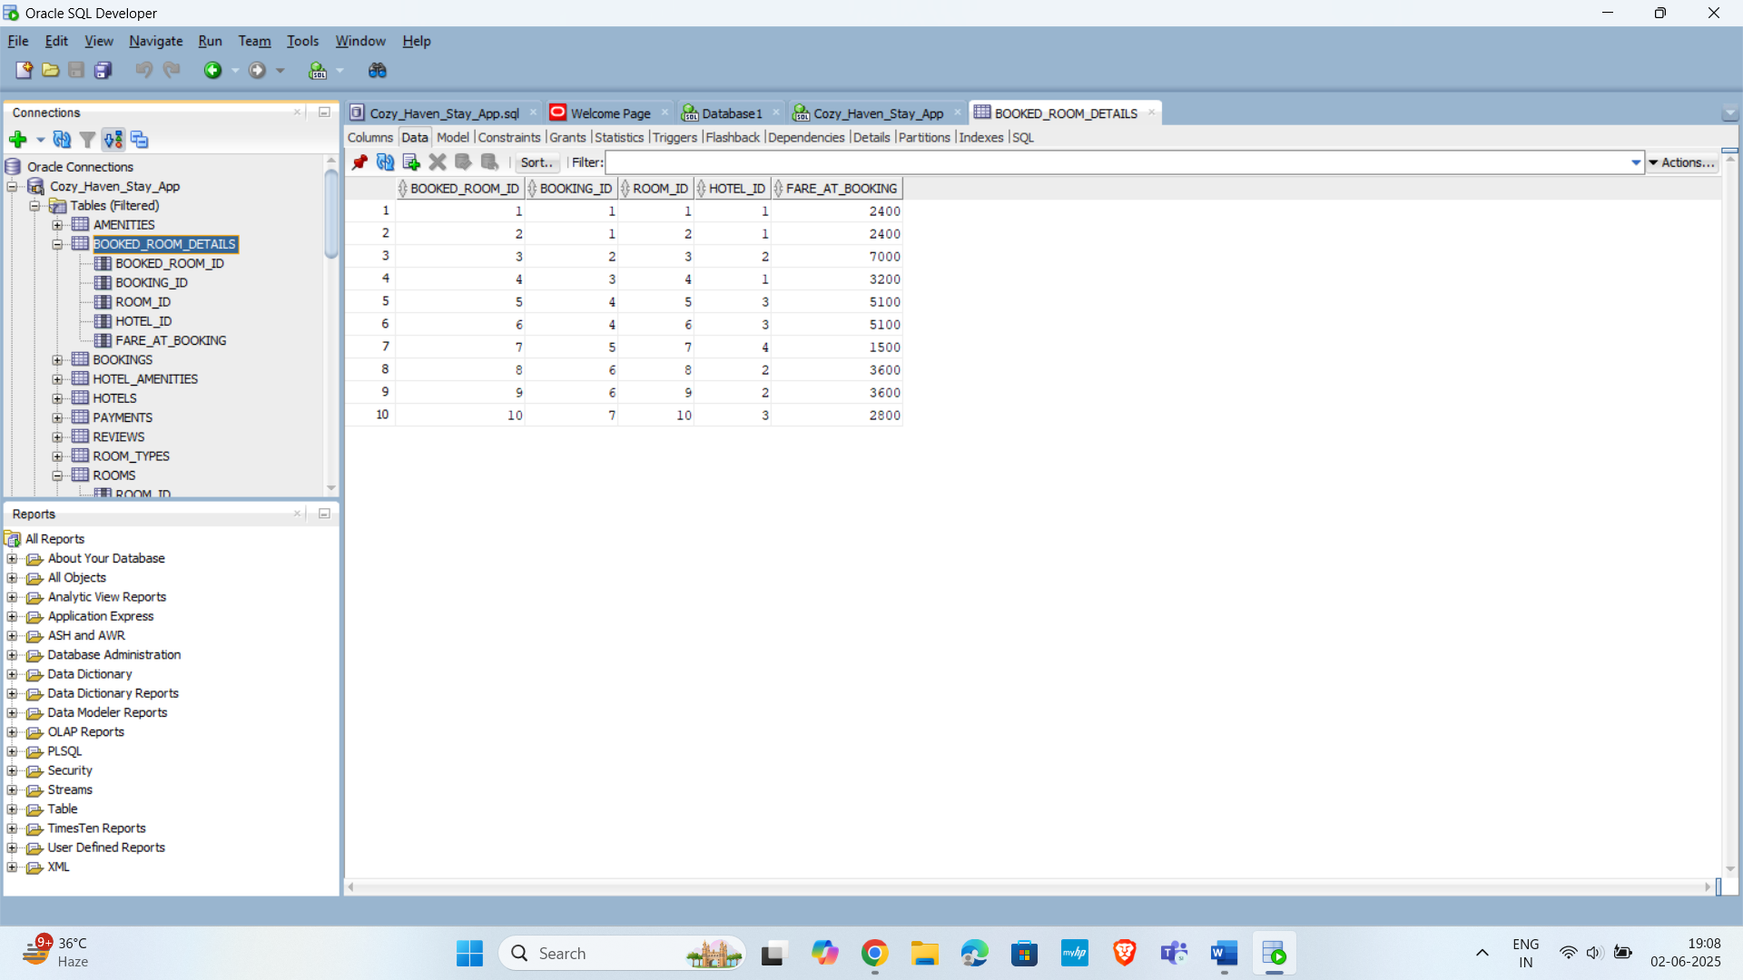

**7.Amenities**

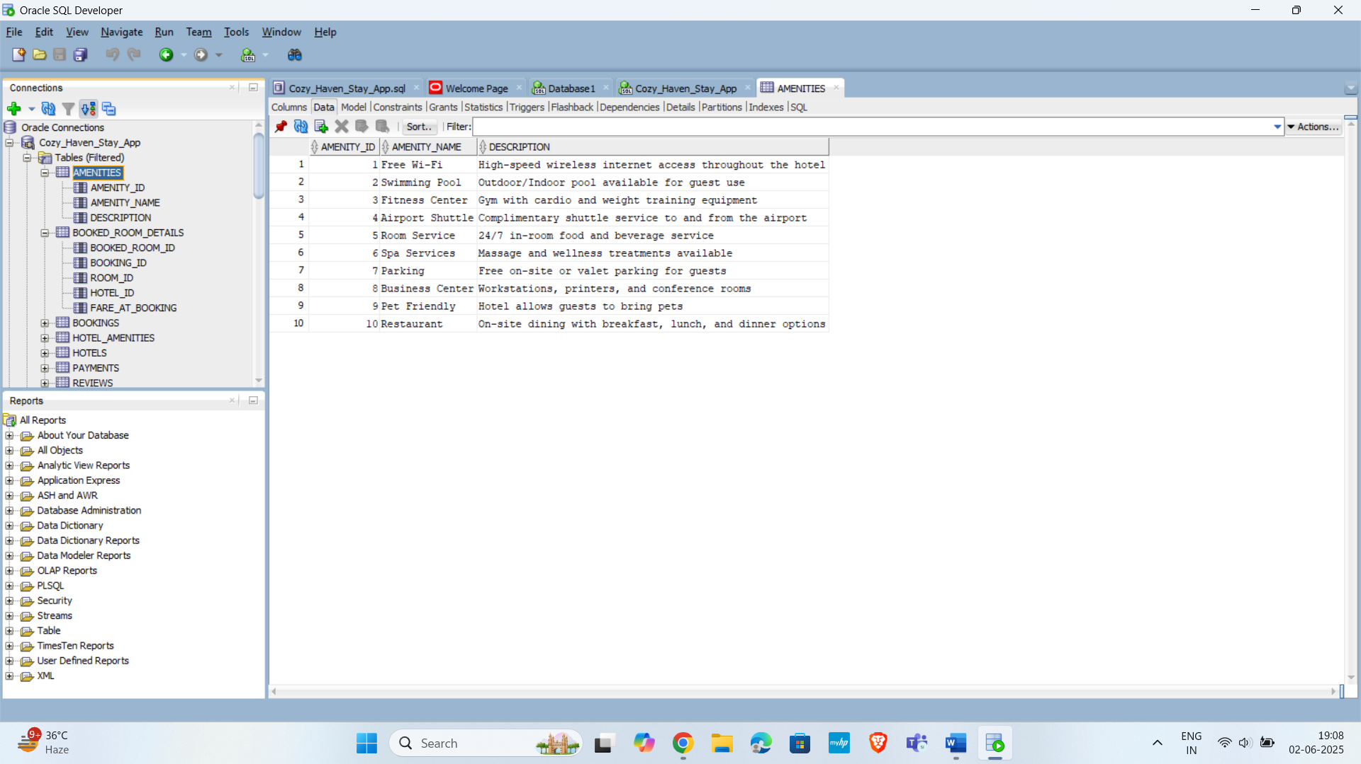

**8.Hotel_Amenities**

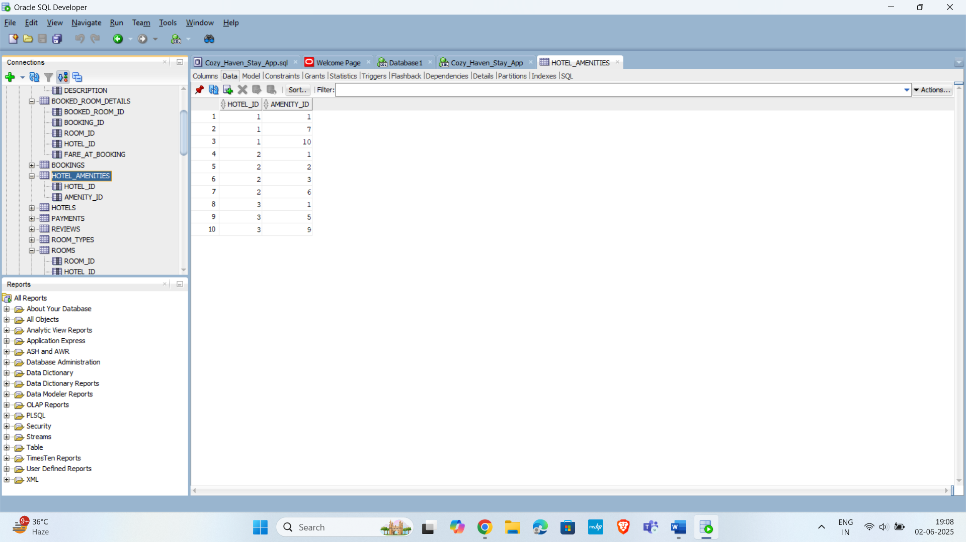

**9.Payments**

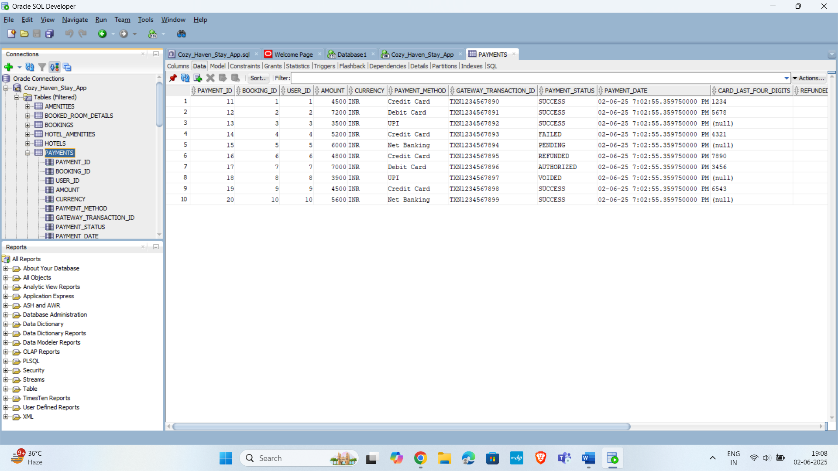

**10.Reviews**

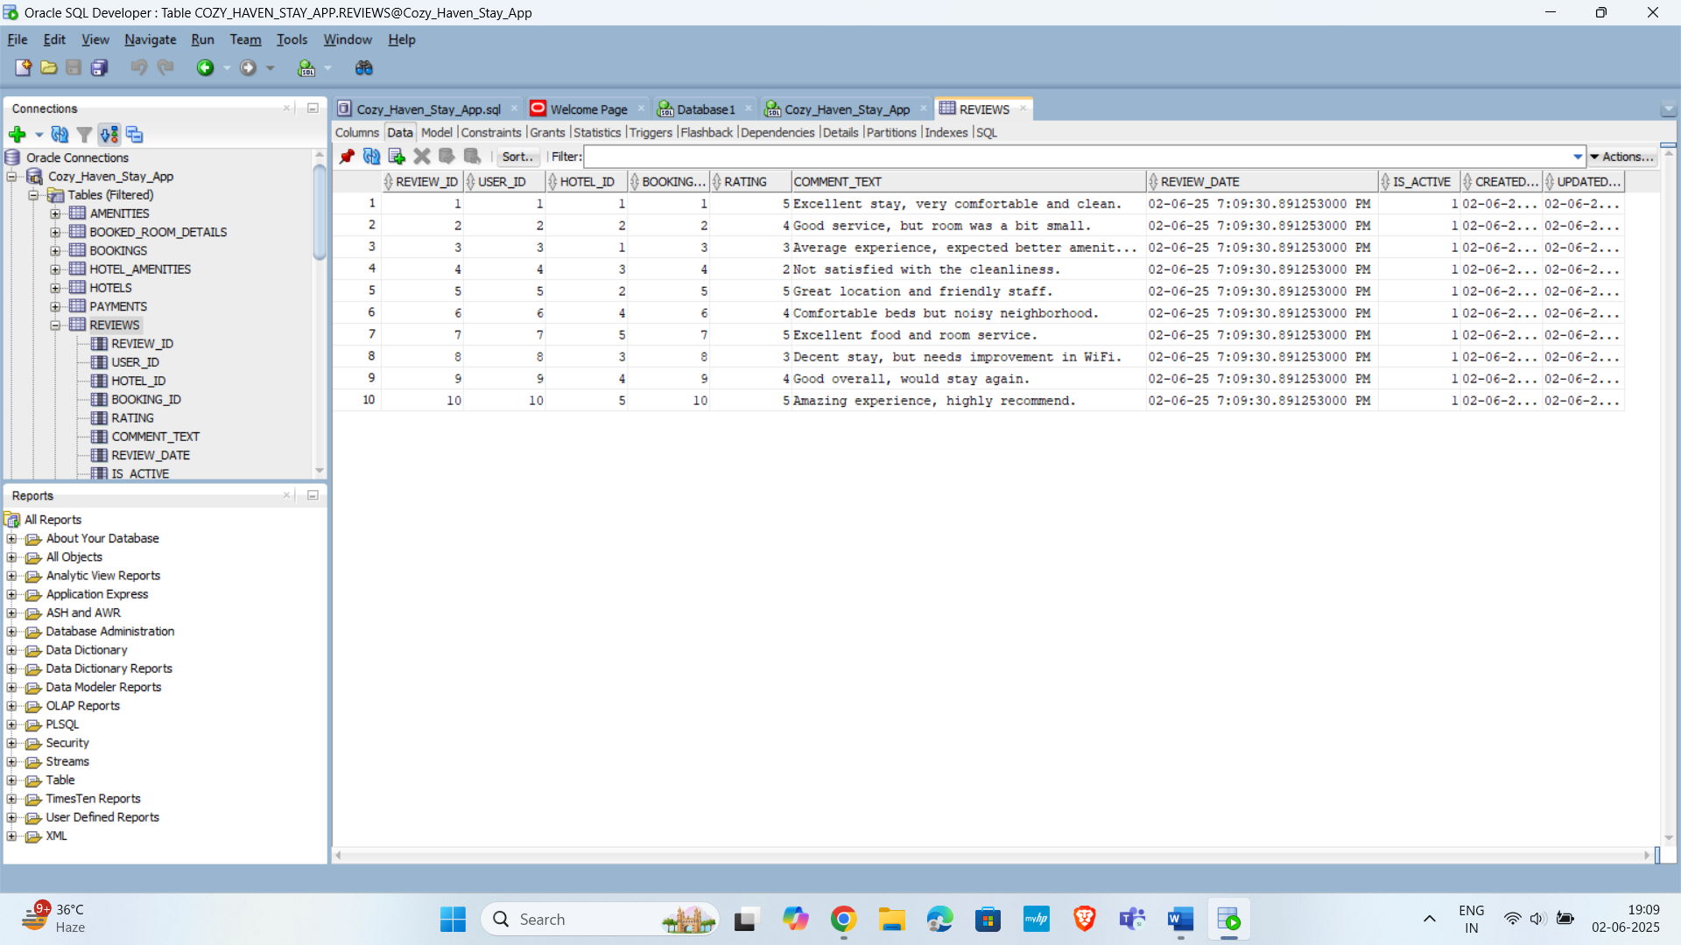

**Indexing**

When designing a database for web-based applications, indexes are not just beneficial, they are absolutely critical for performance, scalability, and providing a good user experience hence I have used indexes in various places Cozy Haven Stay App for optimization.

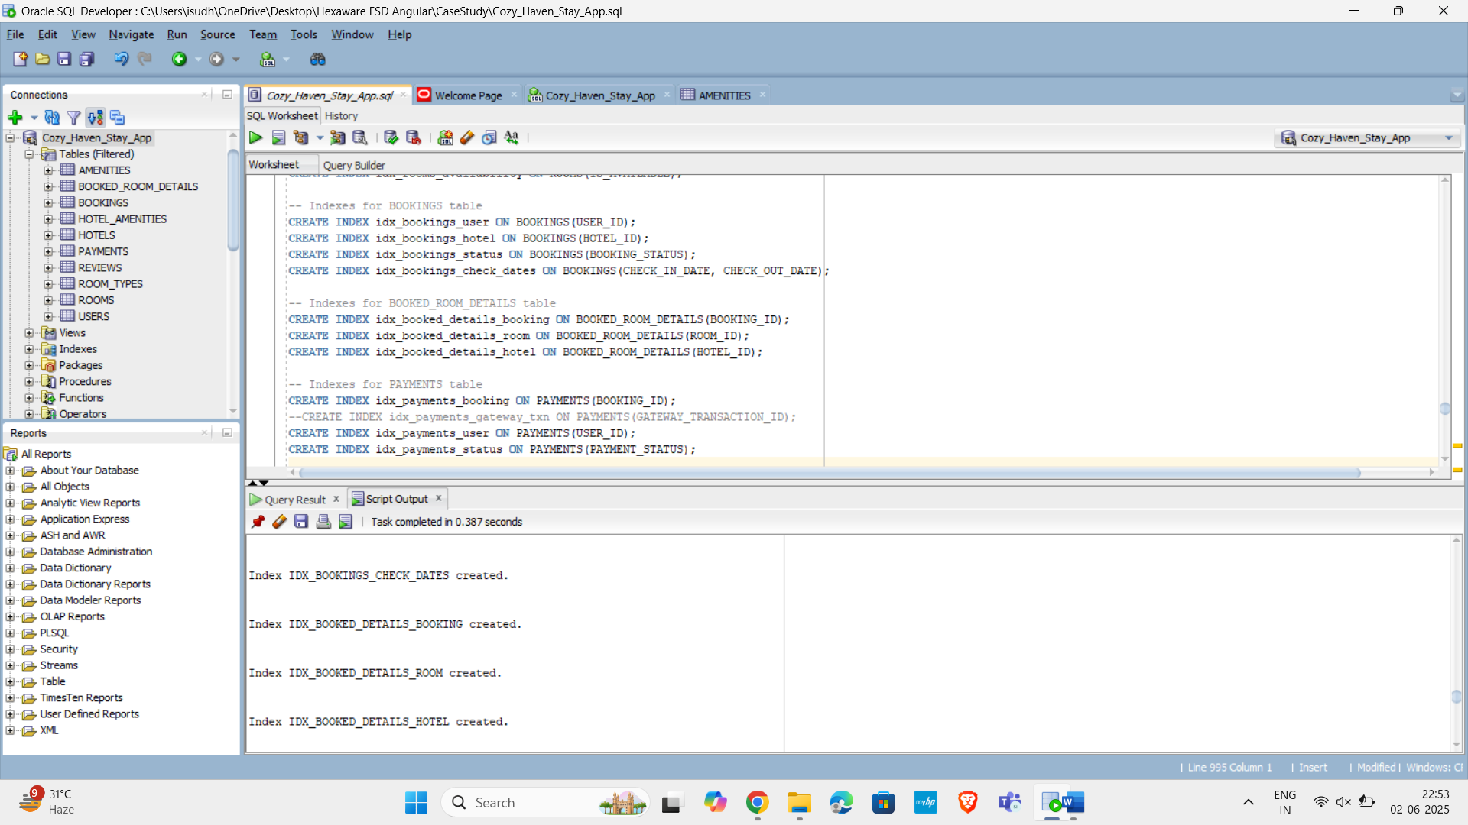

**Checking the Database Design: Practical Operations**

**SQL**

**1. Hotels with Specific wifi Amenities Owned by Indian Hotel Owners**

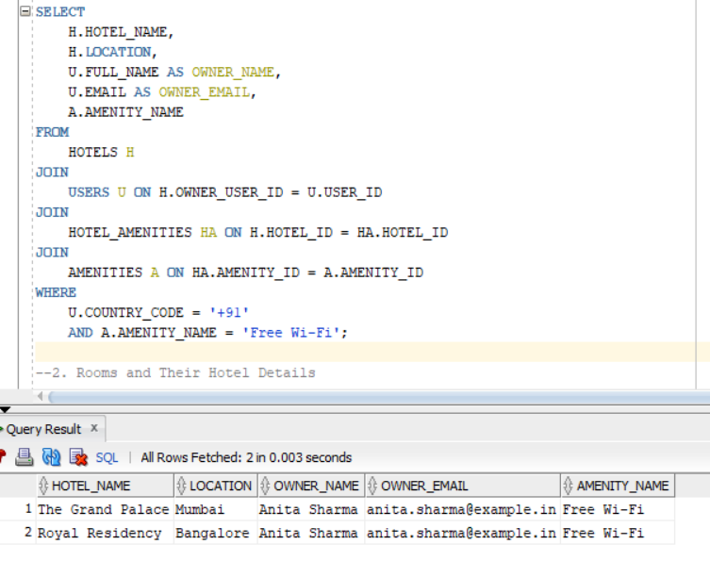

**2. Rooms and Their Hotel Details**

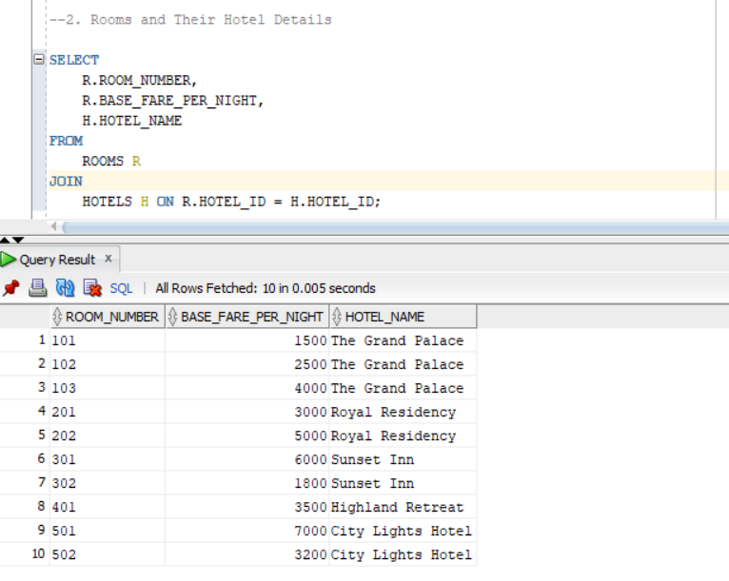

**3. Bookings with User Information**

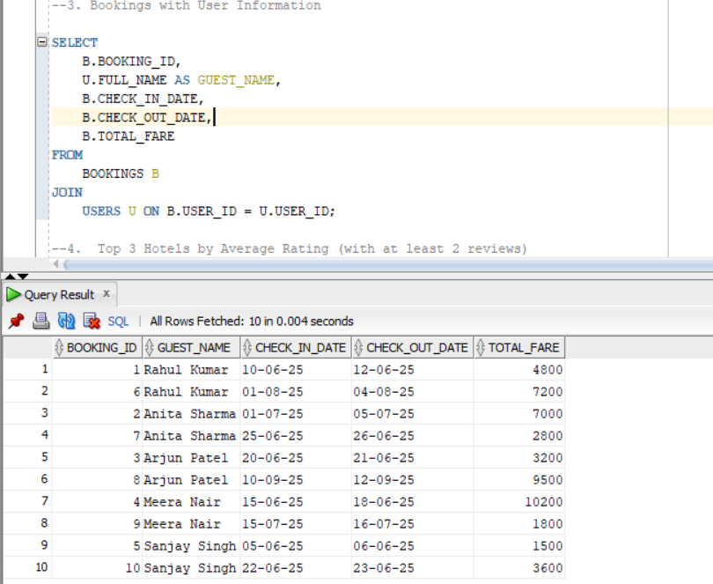

**4.** **Top 3 Hotels by Average Rating (with at least 2 reviews)**

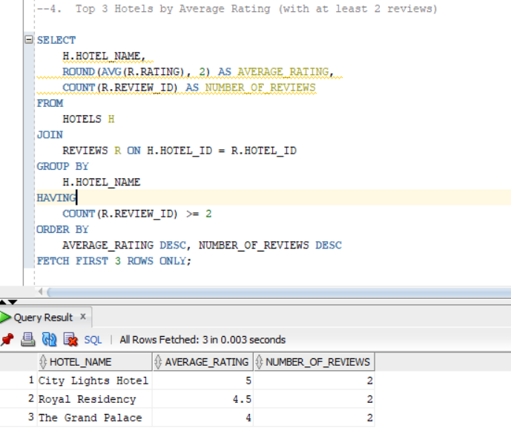

**5. Which Rooms Are Currently Available?**

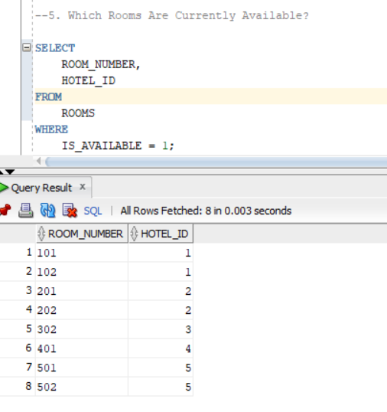

**PL/SQL**

**1. Create a FUNCTION to calculate total feedbacks for a hotel**

CREATE OR REPLACE FUNCTION GET_TOTAL_HOTEL_FEEDBACKS (

p_hotel_id IN HOTELS.HOTEL_ID%TYPE

)

RETURN NUMBER

IS

v_total_feedbacks NUMBER := 0;

BEGIN

SELECT COUNT(*)

INTO v_total_feedbacks

FROM REVIEWS

WHERE HOTEL_ID = p_hotel_id

AND IS_ACTIVE = 1;

RETURN v_total_feedbacks;

EXCEPTION

WHEN NO_DATA_FOUND THEN

RETURN 0;

WHEN OTHERS THEN

DBMS_OUTPUT.PUT_LINE('An error occurred: ' || SQLERRM);

RETURN -1;

END GET_TOTAL_HOTEL_FEEDBACKS;

/

SET SERVEROUTPUT ON; -- To display result in console

DECLARE

v_hotel_id HOTELS.HOTEL_ID%TYPE := 1;

v_hotel_name HOTELS.HOTEL_NAME%TYPE;

v_feedback_count NUMBER;

BEGIN

SELECT HOTEL_NAME INTO v_hotel_name FROM HOTELS WHERE HOTEL_ID = v_hotel_id;

-- Call the function

v_feedback_count := GET_TOTAL_HOTEL_FEEDBACKS(v_hotel_id);

DBMS_OUTPUT.PUT_LINE('Hotel: ' || v_hotel_name || ' (ID: ' || v_hotel_id || ')');

DBMS_OUTPUT.PUT_LINE('Total Active Feedbacks: ' || v_feedback_count);

EXCEPTION

WHEN NO_DATA_FOUND THEN

DBMS_OUTPUT.PUT_LINE('Error: Hotel with ID ' || v_hotel_id || ' not found.');

WHEN OTHERS THEN

DBMS_OUTPUT.PUT_LINE('An unexpected error occurred: ' || SQLERRM);

END;

**Output**

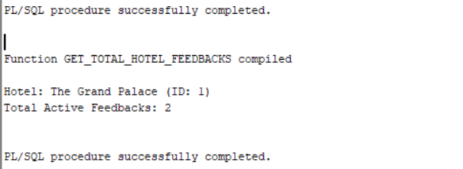

**2. Identify all registered users who haven't made any bookings yet, so we can target them with special offers.**

SET SERVEROUTPUT ON;

DECLARE

CURSOR c_inactive_users IS

SELECT

u.USERNAME,

u.EMAIL,

u.REGISTRATION_DATE

FROM

USERS u

LEFT JOIN

BOOKINGS b ON u.USER_ID = b.USER_ID

WHERE

b.BOOKING_ID IS NULL -- User has no associated bookings

AND u.USER_TYPE = 'GUEST' -- Assuming we only care about 'GUEST' users

ORDER BY

u.REGISTRATION_DATE DESC;

BEGIN

DBMS_OUTPUT.PUT_LINE(' Registered Guests with No Bookings ');

DBMS_OUTPUT.PUT_LINE('Username | Email | Registration Date');

DBMS_OUTPUT.PUT_LINE('------------------+----------------------------------+-------------------');

FOR rec IN c_inactive_users LOOP

DBMS_OUTPUT.PUT_LINE(RPAD(rec.USERNAME, 18) || '| ' || RPAD(rec.EMAIL, 33) || '| ' || TO_CHAR(rec.REGISTRATION_DATE, 'DD-MON-YYYY'));

END LOOP;

DBMS_OUTPUT.PUT_LINE('------------------------------------------------------------------');

EXCEPTION

WHEN OTHERS THEN

DBMS_OUTPUT.PUT_LINE('An error occurred: ' || SQLERRM);

END;

/

**Output:**

